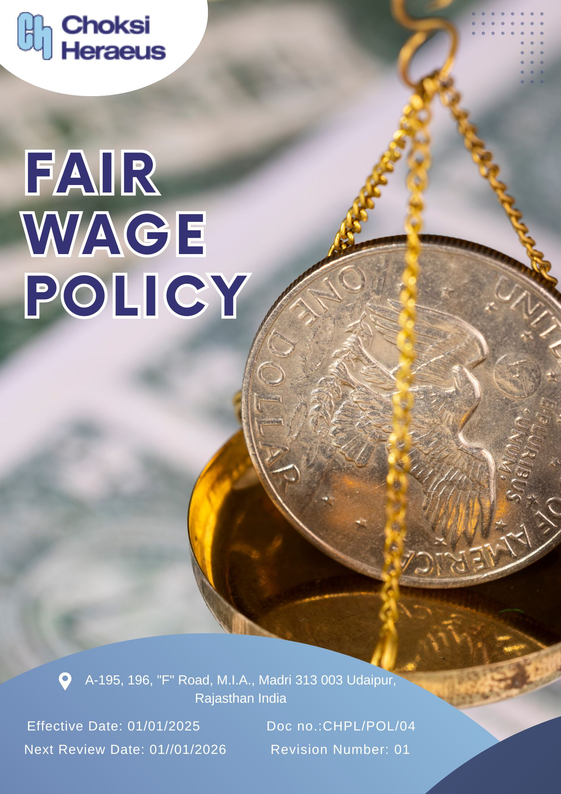

Table of Contents
INTRODUCTION 3
SCOPE 3
POLICY DECLARATION 3
OBJECTIVES AND TARGETS 3
TARGETS IN ALIGNMENT WITH SDGs 4
RESPONSIBILITY 4
REVIEW MECHANISM 5
EMPOLYEE ACKNOWLEDGEMENT FORM 6

INTRODUCTION
Choksi Heraeus is committed to upholding fair and equitable wage practices that support the dignity, well-being, and economic security of all employees. This Fair Wage Policy ensures that all workers receive compensation that meets or exceeds legal requirements, industry standards, and, where applicable, living wage benchmarks. Our approach goes beyond compliance by promoting transparency, internal equity, and consistent wage reviews to address cost of living, inflation, and evolving workforce needs. By fostering a fair wage culture, we aim to create a motivated, productive, and socially responsible workplace.

SCOPE
This policy applies to all employees of Choksi Heraeus, including full-time, part-time, contractual, and third-party workers across all locations. It also encourages fair wage practices among our suppliers and service providers:
Sr. No. | Site | Address
1 | CHOKSI HERAEUS PVT. LTD | A-195, 196, "F" Road, M.I.A., Madri 313 003 Udaipur, Rajasthan India

POLICY DECLARATION
Choksi Heraeus Pvt. Ltd. is committed to paying all employees a Fair wage that reflects the regional cost of living and ensures coverage of essential needs such as food, housing, healthcare, and education. Our wage structure is designed to be regularly reviewed and adjusted based on local economic factors and inflation trends. This commitment goes beyond statutory requirements and aligns with international labor standards and our long-term sustainability goals.

OBJECTIVES AND TARGETS
The FY 2022-23 serves as the baseline for all fair wage-related targets at Choksi Heraeus. This includes commitments to wage equity, living wage alignment, and wage transparency across all employee categories. Progress will be measured against this baseline to ensure continuous improvement and alignment with evolving standards and targets set to achieved by FY 2028-29.
1. Annual Wage Review and Equity
- Ensure equitable wage distribution across departments, considering factors such as performance, gender, and background.
- Conduct annual assessments to ensure wages reflect local living costs and employee well-being.
- Complete annual wage reviews for 100% of employees by March each year.
- Maintain 100% compliance in wage equity audits across all functions.
2. Employee Satisfaction on Fair Wages
- Cultivate a workplace where employees feel their compensation is fair and reflective of their contribution.
- Achieve an employee satisfaction score of 90% on fair wages in surveys by FY 2028-29.
- Ensure that 100% of wage revision communications are transparently shared with employees.
3. Performance-Based Wage Increases
- Implement a transparent, merit-driven wage increase system linked to individual performance and skill enhancement.
- Ensure 50% of employees benefit from performance-based wage increments annually.

TARGETS IN ALIGNMENT WITH SDGs
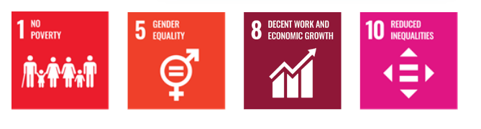

RESPONSIBILITY
The Human Resources Manager shall be responsible for compiling and maintaining the Fair Wage Performance Report in consultation with:
- Finance Department: To provide accurate financial and wage-related data.
- Performance Management Team: For identifying wage increases linked to skill development and performance.
The final report will be submitted annually to senior management and shared with employee representatives to promote transparency.

REVIEW MECHANISM
The Fair Wage Policy will be reviewed annually by the HR Manager, in collaboration with the Management. The review will evaluate the relevance of the policy in light of:
- Local inflation and living costs
- Industry wage benchmarks
- Internal wage equity and employee feedback

Updates will be made as necessary to ensure continued alignment with Choksi Heraeus’ values and international best practices.
Effective Date: 01.01.2025
Next Review Date: 01.01.2026
Approved By:

EMPOLYEE ACKNOWLEDGEMENT FORM
I acknowledge that I have received and reviewed the Fair Wage Policy of Choksi Heraeus Pvt. Ltd. I understand the company’s commitment to providing fair and adequate compensation that reflects the cost of living and promotes a dignified standard of living in accordance with global labor principles.
I recognize my responsibility in supporting the objectives of this policy and in contributing to a workplace that values fairness, equity, and respect for labor rights. I confirm my commitment to the principles outlined and agree to report any concerns or inconsistencies through the established reporting channels.

Employee Name  Employee ID  Date  Signature | :_______________________________  :_______________________________ :________________________________  : _______________________________

